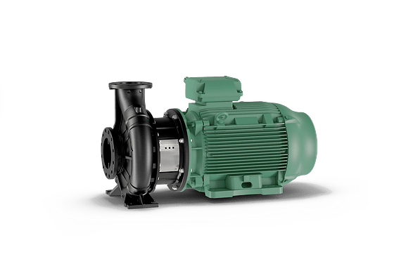
Descriptif pompe Wilo-Atmos GIGA-B
Les pompes seront de norme EN733, type centrifuge monocellulaire basse pression en construction monobloc, tubulure d'aspiration axiale et bride de refoulement radiale à moteur ventilé de marque Wilo type Atmos GIGA-B

Descriptif et fonctionnalités :
Les pompes seront équipées d’un moteur asynchrone de classe IE3 selon IEC 60034-30-2 et d’un indice de rendement hydraulique MEI ≥ 0,4.

De manière générale les pompes devront répondre aux exigences suivantes :
- Dimensions du corps selon EN 733.
- Moteur de classe énergétique IE3 selon IEC 60034-30-2.
- Indice de rendement hydraulique MEI ≥ 0,4.
- Plage de température du fluide de -20°C à 140°C.
- Plage de température ambiante de 0 à 40°C.
- Pression de service maximum de 16b (exécution spéciale : 25b).
- Corps de pompe en fonte avec revêtement cataphorèse, arbre en acier inoxydable, roue en fonte.

