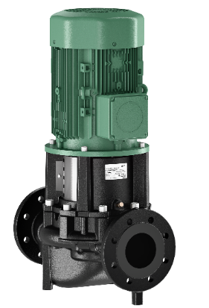
Descriptif pompes
Les pompes simples seront de type centrifuge monocellulaire en ligne à moteur ventilé de marque Wilo type Atmos GIGA-I.
Garantie constructeur de 2 ans.

Descriptif et fonctionnalités :
Les pompes seront équipées d’un moteur asynchrone de classe IE3 selon IEC 60034-30-2 et d’un indice de rendement hydraulique MEI ≥ 0,7.

De manière générale les pompes devront répondre aux exigences suivantes :
- Moteur(s) de classe énergétique IE3 selon IEC 60034-30-2.
- Indice de rendement hydraulique MEI ≥ 0,7.
- Plage de température du fluide de -20°C à 140°C jusqu’à 13 bar et de -20°C à 120°C jusqu’à 16 bar
- Plage de température ambiante de 0 à 40°C.
- Pression de service maximum de 16b (25 bar sur demande).
- Corps de pompe en fonte grise avec revêtement cataphorèse, arbre en acier inoxydable, roue en fonte grise, bronze, acier inoxydable (option)
- Exécutions spéciales possibles :
  - Garniture mécanique S1 pour les applications eau/glycol, teneur en huile dans le fluide
  - Garniture mécanique S2 pour émulsions eau-huile
  - Garniture mécanique S5 pour les applications eau/glycol, aucune teneur en huile dans le fluide
  - Garniture mécanique S6 pour des applications à huile avec des éléments abrasifs

Wilo-Atmos GIGA-I

