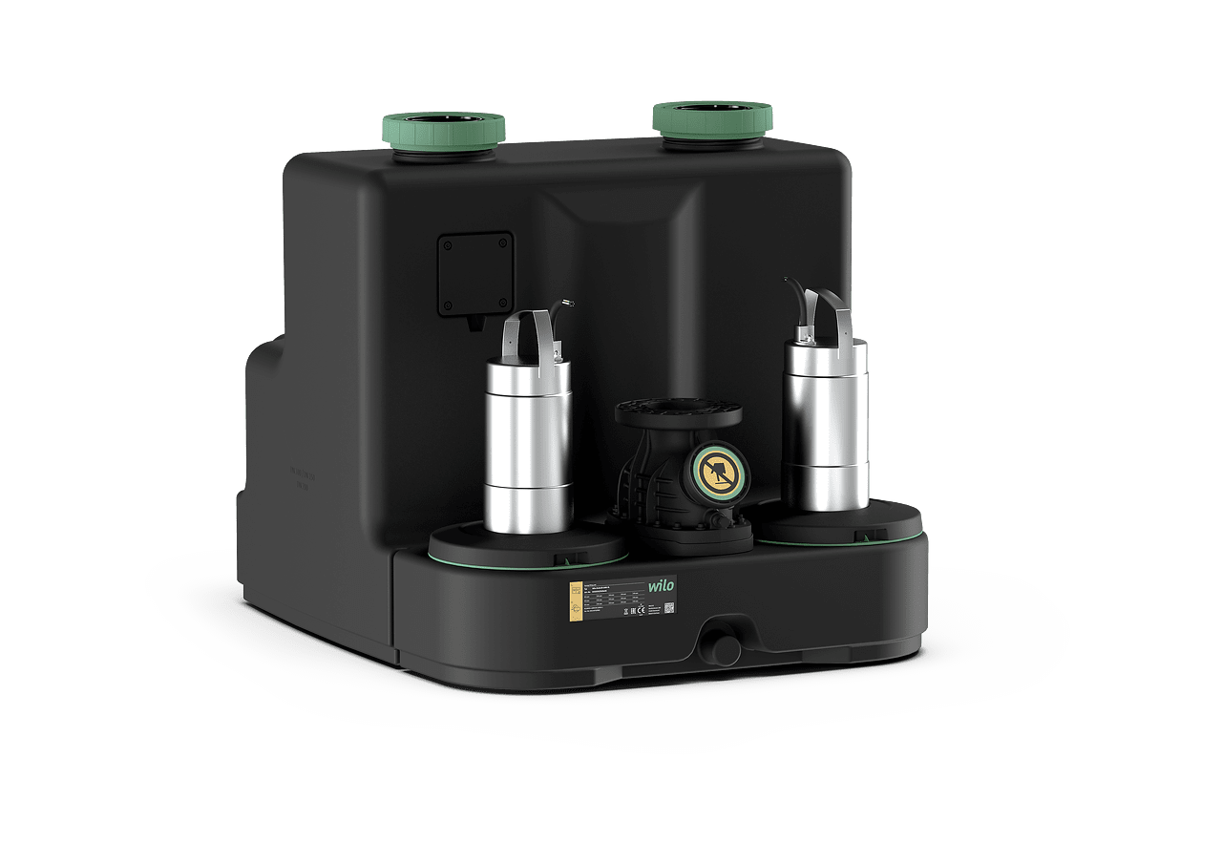
Descriptif station de relevage
La station de relevage sera de marque Wilo type DrainLift SANI-XL.
Garantie constructeur de 2 ans et mise en service par le fabricant.

Descriptif et fonctionnalités :
Station de relevage à pompe double compacte, prête à être branchée et à moteurs immergés pour le pompage des eaux chargées et eaux vannes en matières fécales (norme DIN EN12050-1).

Coffret de commande type Wilo-Control MS-L ou Wilo-Control EC-L préinstallé pour le fonctionnement automatique. Cuve avec ouverture d'entretien et couvercle transparent. Clapet antiretour avec ouverture d'entretien.

Installation sur dalle béton, fosse béton, fosse plastique à l’intérieur ou à l’extérieur d’un bâtiment.
Station de relevage en fosse sèche avec moteur extérieur et hydraulique immergé, réservoir collecteur étanche au gaz et à l’eau et protection contre les poussées, permettant une meilleure maitrise des nuisances hygiéniques sur site par une maintenance limitée ainsi qu’une meilleure maitrise des odeurs et aérosols via une cuve fermée.
Le coffret de commande n'est pas immergé et doit donc être disposé de façon à ce qu'il soit protégé contre la submersion.

De manière générale la station de relevage devra répondre aux exigences suivantes :
  - Plage de température des effluents de 3°C à 40°C, brièvement 65°C pour 5 minutes
  - Granulométrie de passage de 44 ou 65 mm suivant modèle.
  - Cuve en polypropylène, carter moteur en acier inoxydable et hydraulique en polypropylène et polyuréthane.
  - Classe de protection (sans coffret de commande) IP 68.
  - Volume brut de la cuve de 358 litres.
  - Surveillance thermique du moteur.
  - Pilotage du niveau avec capteur de niveau.
  - Mode de fonctionnement : S3 10% ou S1 suivant le coffret de commande.
Equipement :
- M = alimentation réseau monophasée 1~230 V, 50 Hz.
- T = alimentation réseau triphasée 3~400 V, 50 Hz.
- C = version pour fluides agressifs.
- 1 = mode de fonctionnement : S3 avec coffret de commande Wilo Control MS-L avec report de défauts centralisé avec contacts secs, alarme intégrée et indépendante du réseau, temporisation réglable et câble de raccordement 1,5 m avec fiche intégrée.
- 4 = mode de fonctionnement : S1 avec coffret de commande Wilo Control EC-L avec report de défauts centralisé avec contacts secs, alarme intégrée et indépendante du réseau, temporisation réglable et câble de raccordement 1,5 m avec fiche intégrée.

Wilo-DrainLift SANI-XL

