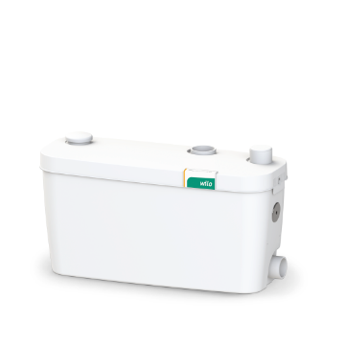
Descriptif station de relevage
La station de relevage sera de marque Wilo type HiDrainLift 3.
Garantie constructeur de 2 ans.

Descriptif et fonctionnalités :
Mini-station de relevage pour le pompage des eaux usées sans matières fécales (selon la norme DIN EN 12050-2) ne pouvant pas être évacuées vers le réseau d'assainissement par inclinaison naturelle.
Station de relevage prête à être branchée, automatique Station de relevage très compacte, silencieuse et fonctionnant automatiquement selon EN 12050-2, pour installation sous une douche ou dans les armoires basses, dotée de tous les équipements de commutation et de commande nécessaires, clapet anti-retour monté et 2-3 tubulures d'aspiration (en fonction du modèle).
Jusqu'à trois possibilités de raccordement pour le drainage de lavabo, baignoire, douche, bidet, machine à laver, lave-vaisselle ou évier.
Dégazage par le biais d'un filtre à charbon actif inodore dans la pièce d'installation.

De manière générale la station devra répondre aux exigences suivantes :
- Plage de température du fluide de 0°C à 35°C (jusqu’à 75 °C pendant 5 minutes suivant modèle)
- Volume de réservoir de 3,9 litres, 15,5 litres ou 16 litres suivant modèles.
- IP 44, classe de protection F
- Protection thermique du moteur intégrée

Wilo-HiDrainLift 3

