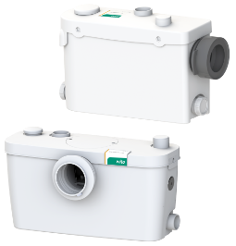
Descriptif station de relevage
La station de relevage sera de marque Wilo type Hisewlift 3.
Garantie constructeur de 2 ans.

Descriptif et fonctionnalités :
Mini-station de relevage pour le pompage des eaux usées sans matières fécales (selon la norme DIN EN 12050-2) ne pouvant pas être évacuées vers le réseau d'assainissement par inclinaison naturelle.
Station de relevage pour le pompage des eaux chargées en matières fécales (selon DIN EN 12050-1) qui ne peuvent pas être conduites aux égouts grâce à l'inclinaison naturelle.
Mini-station de relevage fonctionnant automatiquement avec dilacérateur, clapet anti-retour monté, filtre à charbon actif, bride de refoulement élastique ainsi que des possibilités de raccordement pour des toilettes et - en fonction du modèle - deux ou trois articles de drainage supplémentaires. Le dégazage a lieu par le biais d'un filtre à charbon actif inodore dans la pièce d'installation.

De manière générale la station devra répondre aux exigences suivantes :
- Plage de température du fluide de 0°C à 35°C
- Volume de réservoir de 14,4 litres ou 17,4 litres suivant modèles.
- IP 44, classe de protection F
- Contrôle de niveau par capteur de pression pneumatique pour éviter tout contact avec le liquide véhiculé
- Protection thermique du moteur intégrée

Wilo-Hisewlift 3

