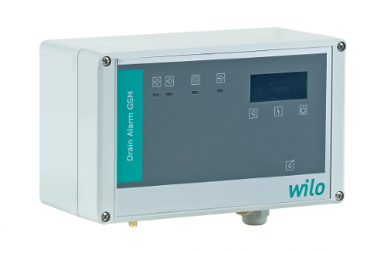

Descriptif coffret
Wilo-DrainAlarm
L’alarme associée au poste de relevage sera de marque Wilo type DrainAlarm.
Garantie constructeur de 2 ans.

Descriptif et fonctionnalités :
Coffret d'alarme indépendant du secteur (bloc d'alimentation à recharge automatique) pour montage mural, avec message d'alerte optique et sonore.

Interrupteur à flotteur pour la saisie du niveau à prévoir en accessoire supplémentaire.

Le coffret de commande n’est pas protégé contre les explosions et ne doit être utilisé qu'en dehors des secteurs à risque d'explosion. Le capteur de signal au sein des zones à risques d'explosion doit être raccordé via un circuit électrique à sécurité intrinsèque, par exemple une barrière de sécurité à diodes ou un relais d'isolation.

De manière générale l’alarme devra répondre aux exigences suivantes :
  - Visualisation en façade par voyant (vert, jaune, rouge).
  - Alarme sonore avec signal d'alarme de 85 dBA.
  - Construction en polycarbonate.
  - Protection IP68.
  - Alimentation réseau : 1~230V, 50/60 Hz.
  - Plage de température ambiante de -20°C à 50°C.
  - Humidité de l’air relative max. : 50%.

Entrées :
- 1 entrée numérique pour la connexion d'un interrupteur à flotteur.
Sorties :
- 1 sortie d’alarme à contact sec (contact inverseur de puissance de connexion : 250 V CA/CC, 4 A) pour transmission du signal d’alarme à des systèmes de commande à distance.
- 1 sortie d’alarme à contact sec (contact à fermeture lié au potentiel, puissance de connexion : 12 V CC, 1 A) pour raccordement d’accessoires externes d’alarme : klaxon ou gyrophare.

