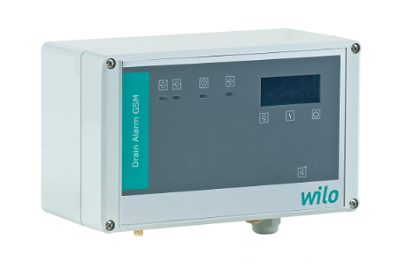

Descriptif alarme
Wilo-DrainAlarm
L’alarme associée au poste de relevage sera de marque Wilo type DrainAlarm.
Garantie constructeur de 2 ans.

Descriptif et fonctionnalités :
Coffret d'alarme indépendant du secteur (bloc d'alimentation à recharge automatique) pour montage mural, avec message d'alerte optique et sonore.
Le capteur de signal doit être fourni par le client. Les coffrets de commande ne sont pas protégés contre les explosions et ne doivent être utilisés qu'en dehors des secteurs à risque d'explosion. Les capteurs de signaux au sein des zones à risques d'explosion doivent être raccordés via un circuit électrique à sécurité intrinsèque, par exemple une barrière de sécurité à diodes ou un relais d'isolation.

De manière générale l’alarme devra répondre aux exigences suivantes :
  - Visualisation en façade par voyant (vert, jaune, rouge).
  - Alarme sonore avec signal d'alarme de 85 Dba.
  - Construction en polycarbonate.
  - Protection IP54.
  - Alimentation réseau : 1~230V, 50/60 Hz.
  - Plage de température ambiante de -20°C à 50°C.

Entrées :
- 1 entrée numérique pour la connexion d'un interrupteur à flotteur.
Sorties :
- 1 inverseur libre de potentiel, puissance de connexion : 230 V CA, 1 A.
- 1 inverseur lié au potentiel, puissance de connexion : 12 V CC, 1 A.

Option, version DrainAlarm GSM : coffret d'alarme indépendant du réseau pour le montage mural avec alerte optique, acoustique et radio (par GSM), ainsi qu'une connexion pour un interrupteur à flotteur pour l'acquisition du niveau.

