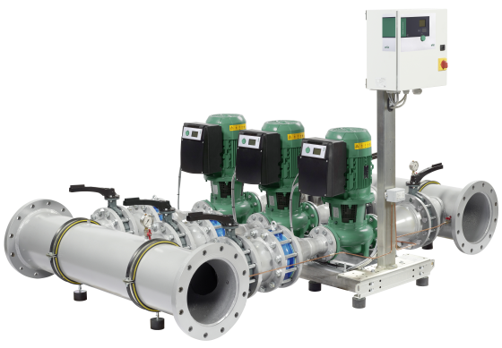
Descriptif SKID HVAC
Dédié aux réseaux à débit variable de chauffage et d’eau glacée, le groupe de pompes électroniques en cascade « SKID » sera de marque Wilo type SiFlux.
Garantie constructeur de 2 ans et mise en service par le fabricant.

Descriptif et fonctionnalités :
Les systèmes multi-pompes à haut rendement WILO type SiFlux sont entièrement automatiques et prêts à être branchés dans les installations de chauffage et de refroidissement à gros débits.
Grâce à son mode de fonctionnement en cascade, le SiFlux offre une alternative efficace aux grosses pompes, lourdes, encombrantes et énergivores. Son coffret de contrôle et de commande démarre, permute ou arrête les pompes et modifie la vitesse de rotation de la pompe principale jusqu’à ce que la consigne de delta pression entrée soit atteinte. Ainsi le temps de fonctionnement de chaque pompe est réduit, leur durée de vie est accrue, la consommation d’énergie électrique est considérablement réduite, le tout dans un confort acoustique optimal :
- Gain de place en comparaison avec une solution pompes sur socle.
- Puissance totale installée réduite en comparaison avec une solution pompes sur socle.
- Gestion de la cascade au meilleur point de rendement des pompes.
- Gain de consommation électrique.
- Facilité de maintenance accrue.
Module compact pré-monté comprenant :
  - Ensemble monobloc livré prémonté sur châssis avec plots anti-vibratile.
  - Collecteurs galvanisés.
  - Vannes d’isolement à l’aspiration et au retour.
  - Clapet anti retour à double battants pour chaque pompe.
  - Capteur de pression différentiel.
  - 3 ou 4 pompes pilotées par un coffret de commande.
  - Coffret de commande type W-CTRL SCe.
La gestion de la cascade des pompes se fera au travers de ce coffret de commande associé au capteur de pression différentiel pour permettre une régulation en différentiel de pression, ∆p. Le coffret assure également la protection des pompes.
Le coffret de commande permettra d’accompagner les variations de débit du réseau tout en régulant la hauteur manométrique. Le choix des fonctions et les valeurs de réglage sont directement lisibles sur l’écran du coffret.
De manière générale le groupe de pompe devra répondre aux exigences suivantes :
- Plage de température du fluide de -20°C à 120°C.
- Plage de température ambiante de 0 à 40°C.
- Pression de service maximum de 16b pour les modèles équipés de pompes Stratos GIGA ou IL-E et 10b pour les modèles équipés de pompes IP-E.
- Gestion automne de la cascade de pompe avec reports de défaut et de marche.
- Protection moteur intégrale avec déclencheur électronique intégré.
- Classification moteur et rendement suivant le modèle de pompe.

Wilo-SiFlux

