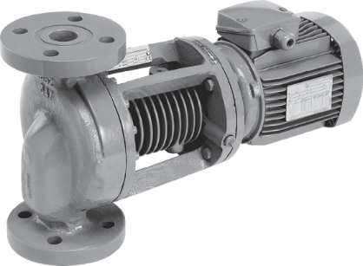
Descriptif pompe
Les pompes seront de type centrifuge monocellulaire en ligne à moteur ventilé de marque Wilo type VeroLine-IPH-W.
Garantie constructeur de 2 ans.

Descriptif et fonctionnalités :
Les pompes seront auto-refroidies et destinées aux transports d’eau surchauffée.
Il n’y aura pas de circuit annexe d’eau de refroidissement à prévoir.
Brides et contre-brides à double emboîtement mâle-femelle, assurant une parfaite étanchéité à la pompe installée quel que soit le liquide véhiculé.

Les pompes seront équipées d’un moteur asynchrone de classe IE3 selon IEC 60034-30-2 et d’un indice de rendement hydraulique MEI ≥ 0,4.

De manière générale les pompes devront répondre aux exigences suivantes :
- Moteur de classe énergétique IE3 selon IEC 60034-30-2.
- Indice de rendement hydraulique MEI ≥ 0,4.
- Plage de température du fluide de -10°C à 210°C.
- Plage de température ambiante de 0 à 40°C.
- Pression de service maximum de 23b.
- Corps de pompe en acier moulé, arbre en acier inoxydable, roue en fonte.

Wilo-VeroLine-IPH-W

