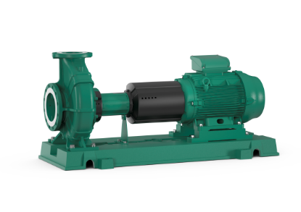
Descriptif pompe
Les pompes seront de norme EN733, ISO 5199, dites « normalisées », type centrifuge monocellulaire, basse pression en construction monobloc, tubulure d'aspiration axiale et bride de refoulement radiale à moteur ventilé de marque Wilo type Atmos GIGA-N.
Garantie constructeur de 2 ans.

Descriptif et fonctionnalités :
Arbre et paliers renforcés pour répondre à la norme ISO 5199.
Pompes montées sur un châssis rigide en fonte pour assurer une meilleure rigidité de l’ensemble.
Les points de fonctionnement seront sélectionnés dans la plage d’utilisation conforme à la norme ISO 5199, afin de réduire les vibrations induites par la pompe.
Les pompes seront prévues en accouplement démontable simple et rapide avec démontage par l'arrière
L’ensemble des composants en fonte disposeront d’un revêtement par cataphorèse pour une résistance maximale à la corrosion.

Les pompes seront équipées d’un moteur asynchrone de classe IE3 selon IEC 60034-30-2 et d’un indice de rendement hydraulique MEI ≥ 0,4.

De manière générale les pompes devront répondre aux exigences suivantes :
- Dimensions du corps selon EN 733.
- Moteur de classe énergétique IE3 selon IEC 60034-30-2.
- Indice de rendement hydraulique MEI ≥ 0,4.
- Plage de température du fluide de -20°C à 140°C.
- Plage de température ambiante de 0 à 40°C.
- Pression de service maximum de 16b.
- Corps de pompe en fonte avec revêtement cataphorèse, arbre en acier inoxydable, roue en fonte.

Wilo-Atmos GIGA-N

