15/05/2018

**When water flows uphill**Wilo is committed to continuous water supply

**Sustainability is an integral component of the corporate strategy of Dortmund-based pump manufacturer Wilo. But this approach is not just about providing highly efficient products. In fact, the big picture is defined by the interplay between individual factors and global developments, the consequences and effects of which must be dealt with using sustainable solutions. One of the global megatrends of our times is the growing water shortage on our planet, an issue that is particularly important to Wilo colleagues all over the world. Thanks to the donation of a submersible motor pump in Morocco, the inhabitants of the village of Imlil have access to running water for the first time.**

The metropolis of Marrakech opens up like an oasis against the backdrop of the impressive Atlas mountain range. Winding alleys, markets glowing in the misty yellow light of thousands of pendant lamps in the evenings. Next to it the modern Orient: luxury hotels, expansive golf courses and exclusive cocktail bars. A ninety-minute drive to the south and a completely different Morocco starts to emerge: towering snow-capped mountains, the scenery is becoming rougher, small Berber villages and cactuses. At an elevation of 4,167 metres, Mount Toubkal is the highest peak of the Atlas mountain range in the northwest of Africa and a popular destination for hikers. Five employees of the Moroccan subsidiary of the Dortmund pump manufacturer Wilo wanted to take on this challenge: “We wanted to face a new challenge that binds us even closer together as a group. To climb to the peak of highest mountain in our region seemed like the perfect opportunity to us,” explains Imad Boulabat from Wilo Morocco. After a few hours they take a break in the village of Imlil – but replenishing their water supply proves to be more difficult than expected. “We asked the inhabitants what the problem was. The answer was simple: ‘Water is a rare commodity in our region,’ they said,” recalls Boulabat. Around 800 people live in the Berber village. Sixty percent of them are women and children. In order to build up their water supply they have to travel two kilometres each way to the closest well. They have to carry full water containers or large water bottles all the way back to their village. They only use the water for drinking or a quick wash. To do their laundry, the residents of Imlil have to walk to the river. If they want a shower, they will have to walk to the next bathhouse.

**Water shortage as a daily challenge**

In 2010, the United Nations declared access to clean water a human right. Estimates indicate that there are currently around 900 million people without access to clean drinking water, with fatal consequences: every single day, almost 1,000 children under five years old die from diarrhoea caused by contaminated water. By 2040, it is expected that 33 countries across the globe will be affected by extreme water shortages. Morocco is one of the countries that has been battling with the effects of climate change for a long time. Experts believe that precipitation levels will continue to decline in the future, whilst temperatures could continue to rise. Deserts will continue to expand. Morocco’s population will nevertheless continue to grow: the country’s population has almost tripled from 12 to 34 million since the 1960s. 61 percent of Moroccans live in cities and depend on utilities. But water is already in short supply. The World Climate Council expects that many African countries will soon be overexploiting this vital resource: fields need irrigation, so wells are drilled and filled with water supplied by tankers. The overexploitation of water reserves is threatening to upset the balance in a number of regions. According to a forecast by the World Resource Institute for the year 2040, Morocco, Algeria and Libya are on track to consume far more water than what is likely to be available.

**Water for Imlil**  
To enable the residents to have access to running water, the Wilo employees decided to donate a submersible motor pump. The Wilo-Actun FIRST SPU 4 was designed for application in a challenging installation environment. The floating impeller increases the tolerance to sand in the water, as the mobility of the impeller guarantees a higher permeability. The mechanical seal additionally protects the motor from external influences. With high motor efficiencies, the submersible motor pump ensures a high water yield with low energy consumption.

The pump and motor were installed in cooperation with a local technician.  
“Thanks to the help of Wilo, running water now comes all the way into our homes. Instead of having to walk every day to get water, we now have more time to generate an income. We have more time to weave the carpets that we then sell on to our neighbours and visitors to our village,” one of the women from the village explains. “But what’s so much more important is the fact that our daughters now have enough time to attend school.”

**Images**  
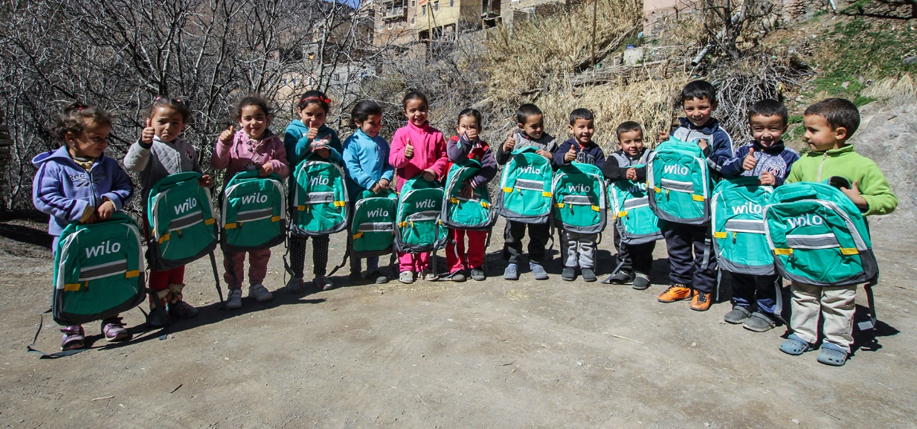

Source: Wilo SE

Caption: The donation of the submersible motor pump means that the village now has access to running water  
Source: Wilo SE

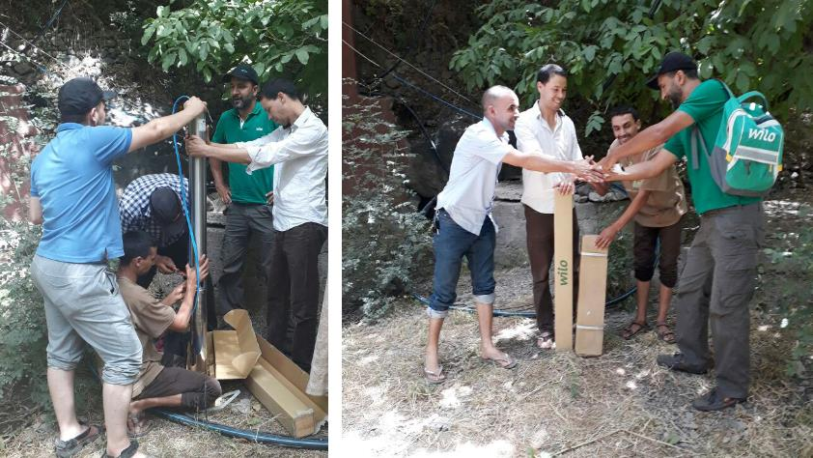

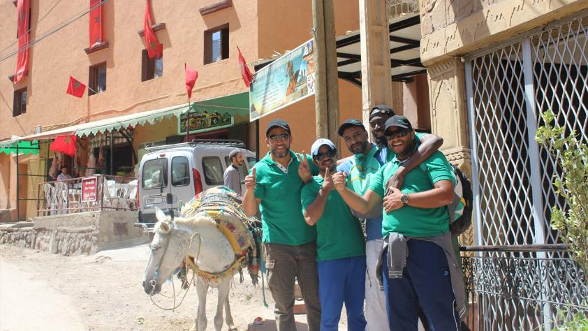

Caption: The Moroccan colleagues of the Dortmund technology company Wilo in Imlil   
Source: Wilo SE

|  |  |  |  |
| --- | --- | --- | --- |
| **Wilo Corporate Communications**  Klaus Hübscher  Phone: +49 231 4102-6606  E-mail: klaus.huebscher@wilo.com | Pia Scherbach  Phone: +49 231 4102-7512  E-mail: pia.scherbach@wilo.com |  |  |

**About Wilo**

WILO SE is one of the world’s leading premium suppliers of pumps and pump systems for building services, water management, and the industrial sector. We are increasingly developing from a component manufacturer to a system supplier and aim to set standards for high-tech in the pumping sector as an international innovation and technology leader. With smart solutions that will connect people, products and services, the Wilo Group is aiming to be the digital pioneer in the sector by 2020. The company owes its success to its workforce of over 7,700 employees in more than 60 subsidiaries around the world.  
  
For more information, visit [www.wilo.com](http://www.wilo.com)